Here I will give you 3 key things that will allows you to become better web developer and keep on growing. Because growing never stops.

1)Practice

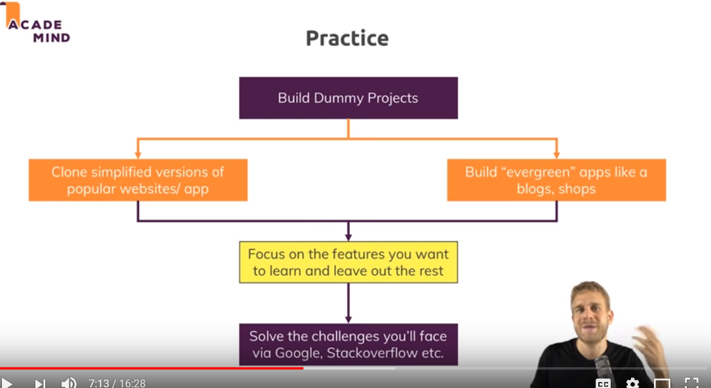

2)Challenge best practices-

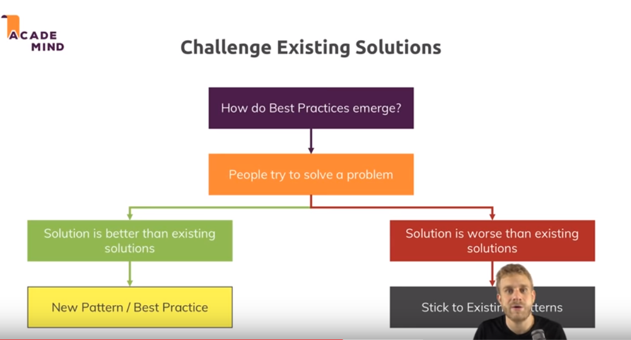

3)discuss & contribute –

